Experiment 9: Multilayer Perceptron Implementation

1. Aim
To build and train a Multilayer Perceptron (MLP) classifier using TensorFlow and Keras to predict customer churn in a telecom company. To preprocess customer data by encoding categorical features and scaling numerical features, construct a neural network with multiple hidden layers using ReLU activation and a sigmoid output layer, train the model using binary cross-entropy and Adam optimizer, evaluate its performance using accuracy, precision, recall, F1-score and confusion matrix, and analyze the effect of hidden-layer width on model performance.

2. Formula(s)
1. Weighted Sum: Z = X × W + b
2. ReLU Activation Function: ReLU(z) = max(0, z)
3. Sigmoid Activation Function: Sigmoid(z) = 1 / (1 + e^(-z))
4. Binary Cross-Entropy Loss: L = -(1/N) × Σ [yi × log(pi) + (1-yi) × log(1-pi)]
5. Accuracy: Accuracy = (TP + TN) / (TP + TN + FP + FN)
6. Precision: Precision = TP / (TP + FP)
7. Recall: Recall = TP / (TP + FN)
8. F1-Score: F1 = 2 × (Precision × Recall) / (Precision + Recall)
9. Adam Optimizer: m(t) = β1 × m(t-1) + (1-β1) × g(t), v(t) = β2 × v(t-1) + (1-β2) × g(t)^2
10. Confusion Matrix: [[TN, FP], [FN, TP]]

3. Overall Flow Diagram
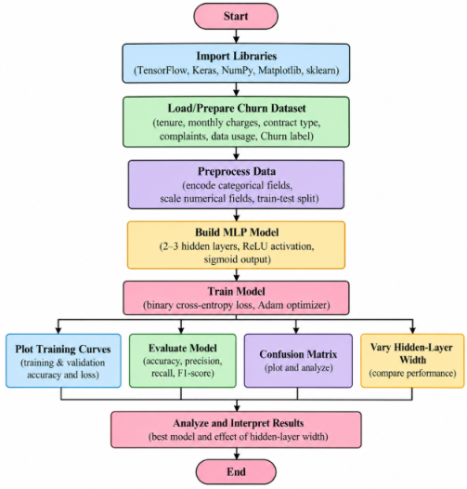

4. Code :
import numpy as np
import pandas as pd
import matplotlib.pyplot as plt
import tensorflow as tf
from sklearn.model_selection import train_test_split
from sklearn.preprocessing import StandardScaler
from sklearn.metrics import (
accuracy_score, precision_score,
recall_score, f1_score,
confusion_matrix, classification_report
)
np.random.seed(42)
tf.random.set_seed(42)
n = 1000
data = pd.DataFrame({
"tenure": np.random.randint(1, 73, n),
"monthly_charges": np.random.uniform(20, 120, n),
"contract": np.random.choice(
["Month-to-month", "One year", "Two year"], n
),
"complaints": np.random.choice(
["Yes", "No"], n, p=[0.35, 0.65]
),
"data_usage": np.random.uniform(1, 100, n)
})
logit = (
2.0
- 0.045 * data["tenure"]
+ 0.018 * data["monthly_charges"]
+ 1.2 * (data["contract"] == "Month-to-month")
- 0.8 * (data["contract"] == "Two year")
+ 1.0 * (data["complaints"] == "Yes")
- 0.012 * data["data_usage"]
)
probability = 1 / (1 + np.exp(-logit))
data["Churn"] = (
np.random.rand(n) < probability
).astype(int)
print("Dataset Sample:")
print(data.head())
print("\nChurn Distribution:")
print(data["Churn"].value_counts())
X = data.drop("Churn", axis=1)
y = data["Churn"].values
X = pd.get_dummies(
X,
columns=["contract", "complaints"],
dtype=int
)
X_train, X_test, y_train, y_test = train_test_split(
X, y,
test_size=0.2,
random_state=42,
stratify=y
)
numeric_columns = [
"tenure", "monthly_charges", "data_usage"
]
scaler = StandardScaler()
X_train.loc[:, numeric_columns] = scaler.fit_transform(
X_train[numeric_columns]
)
X_test.loc[:, numeric_columns] = scaler.transform(
X_test[numeric_columns]
)
X_train = X_train.astype("float32").values
X_test = X_test.astype("float32").values
print("\nTraining Shape:", X_train.shape)
print("Testing Shape:", X_test.shape)
def create_model(width):

model = tf.keras.Sequential([
tf.keras.Input(shape=(X_train.shape[1],)),

tf.keras.layers.Dense(
width, activation="relu"
),

tf.keras.layers.Dense(
width // 2, activation="relu"
),

tf.keras.layers.Dense(
1, activation="sigmoid"
)
])

model.compile(
optimizer=tf.keras.optimizers.Adam(
learning_rate=0.001
),
loss="binary_crossentropy",
metrics=["accuracy"]
)
return model
widths = [8, 16, 32, 64]
histories = {}
models = {}
results = {}
for width in widths:
print("\nTraining Model with Width:", width)
model = create_model(width)
history = model.fit(
X_train,
y_train,
epochs=40,
batch_size=32,
validation_split=0.2,
verbose=0
)
models[width] = model
histories[width] = history.history
test_loss, test_accuracy = model.evaluate(
X_test, y_test, verbose=0
)
predictions = (
model.predict(X_test, verbose=0) >= 0.5
).astype(int).ravel()
precision = precision_score(
y_test, predictions, zero_division=0
)
recall = recall_score(
y_test, predictions, zero_division=0
)
f1 = f1_score(
y_test, predictions, zero_division=0
)
results[width] = [
test_accuracy, precision, recall, f1
]
print("Test Accuracy:", round(test_accuracy, 4))
print("Precision:", round(precision, 4))
print("Recall:", round(recall, 4))
print("F1-Score:", round(f1, 4))
best_width = max(
results,
key=lambda w: results[w][3]
)
best_model = models[best_width]
print("\nBest Hidden Layer Width:", best_width)
history = histories[best_width]
plt.figure(figsize=(9, 5))
plt.plot(history["accuracy"], label="Training Accuracy")
plt.plot(history["val_accuracy"], label="Validation Accuracy")
plt.xlabel("Epochs")
plt.ylabel("Accuracy")
plt.title("Training and Validation Accuracy")
plt.legend()
plt.grid()
plt.show()
plt.figure(figsize=(9, 5))
plt.plot(history["loss"], label="Training Loss")
plt.plot(history["val_loss"], label="Validation Loss")
plt.xlabel("Epochs")
plt.ylabel("Binary Cross-Entropy Loss")
plt.title("Training and Validation Loss")
plt.legend()
plt.grid()
plt.show()
y_probability = best_model.predict(
X_test, verbose=0
)
y_pred = (y_probability >= 0.5).astype(int).ravel()
print("\nCLASSIFICATION REPORT")
print(classification_report(
y_test, y_pred,
target_names=["No Churn", "Churn"],
zero_division=0
))
cm = confusion_matrix(y_test, y_pred)
print("Confusion Matrix:")
print(cm)
plt.figure(figsize=(6, 5))
plt.imshow(cm, cmap="Blues")
plt.colorbar()
plt.xticks([0, 1], ["No Churn", "Churn"])
plt.yticks([0, 1], ["No Churn", "Churn"])
plt.xlabel("Predicted")
plt.ylabel("Actual")
plt.title("Confusion Matrix")

for i in range(2):
for j in range(2):
plt.text(
j, i, cm[i, j],
ha="center", va="center"
)

plt.show()
width_results = pd.DataFrame(
results,
index=["Accuracy", "Precision", "Recall", "F1-Score"]
).T
print("\nHIDDEN LAYER WIDTH COMPARISON")
print(width_results.round(4))
plt.figure(figsize=(9, 5))
for metric in width_results.columns:
plt.plot(
widths,
width_results[metric],
marker="o",
label=metric
)
plt.xlabel("Hidden Layer Width")
plt.ylabel("Performance Score")
plt.title("Effect of Hidden Layer Width")
plt.xticks(widths)
plt.legend()
plt.grid()
plt.show()

5. Output
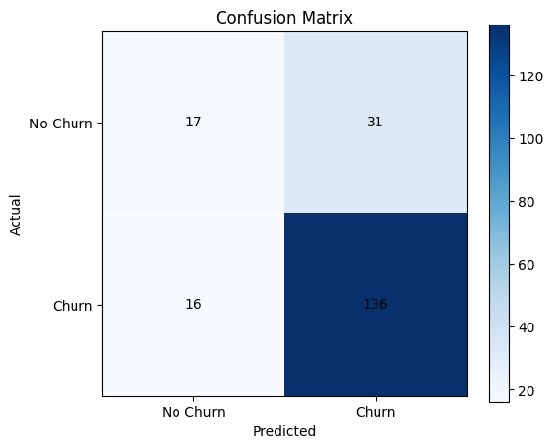
HIDDEN LAYER WIDTH COMPARISON
Accuracy Precision Recall F1-Score
8 0.750 0.7965 0.9013 0.8457
16 0.760 0.8133 0.8882 0.8491
32 0.765 0.8144 0.8947 0.8527
64 0.765 0.8144 0.8947 0.8527

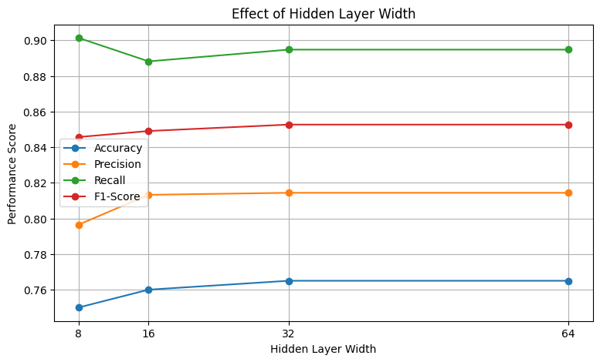

6. Result
A Multilayer Perceptron model was successfully implemented using TensorFlow and Keras to predict customer churn. The model was trained and evaluated using accuracy, precision, recall, F1-score and confusion matrix. Different hidden-layer widths were compared, and training and validation graphs were plotted successfully.

